Ocean features (Pages 432 and 433)
A continental shelf is the flat or gently sloping land that extends underwater from the edge of a continent to a continental slope.
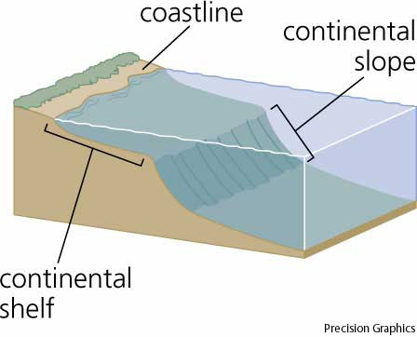
A continental slope is land that drops down steeply at the edge of a continental shelf.
Submarine canyons cut through the continental shelf and slope.
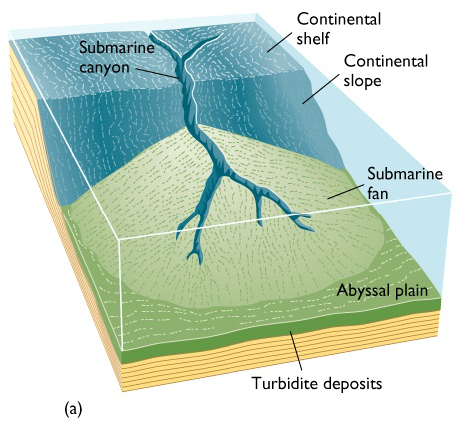
Ocean trenches cut deep into the ocean floor. The Mariana Trench is the deepest place in the world.
An abyssal plain is a wide, flat area of the ocean floor.
A mid-ocean ridge is a chain of mountains that run through an ocean basin………they are the world’s longest mountain range.
Volcanic islands are underwater volcanoes tall enough to reach above the surface.
Seamounts are undersea mountains.
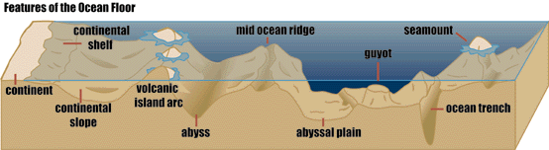

The two methods used to map the ocean floor are sonar and satellites.
Sonar is a system that uses sound waves to measure distances and locate objects. This is used to provide detail of small areas.
Satellites are used to map larger areas. They can detect tiny bumps and dips in the ocean’s height.

An ocean current is a mass of moving water. These currents distribute heat and nutrients around the globe.
Surface currents are caused by winds. They move warm water away from the equator and cool water away from the poles.
The Gulf Stream is an example of a surface current. It moves warm water northeastward toward Great Britain and Europe.
Earth’s rotation curls surface currents clockwise in the Northern Hemisphere and counterclockwise in the Southern Hemisphere.
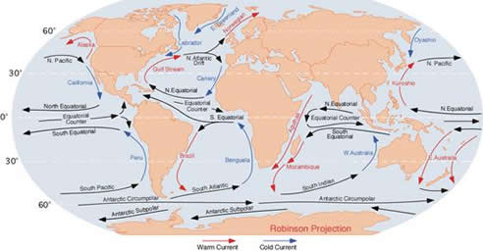
Deep currents are driven by differences in water density. Deep currents involve two processes: downwelling and upwelling.
Downwelling moves water from the surface to greater depths. As the water sinks, it carries oxygen down from the surface.
Upwelling moves water up to the surface. This process brings up nutrients from the deep.
A wave is an up-and-down motion along the surface of a body of water. Waves are usually caused by winds. They may also be caused by earthquakes, landslides, and underwater volcanic eruptions.
The crest is the high point of a wave.
The trough is the low point of a wave.
Wave height is the vertical distance between the top of the crest and the bottom of the trough.
Wavelength is the distance between one wave crest and the next.
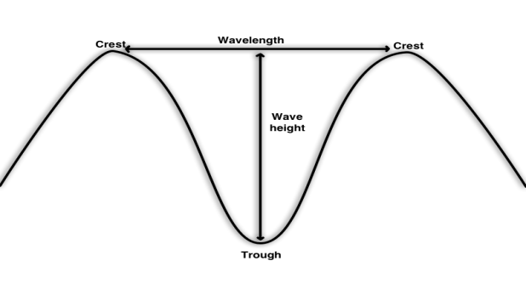

Waves transport energy, not water.
When a wave crashes on shore, water runs back to the sea. This is called undertow.
A longshore current moves water parallel to the shore. Swimmers drift down the beach as a result of a longshore current.
A rip current is a narrow stream of water that breaks through a sandbar and drains rapidly back to sea. Rip currents occur when there is high winds and high waves. These currents are extremely dangerous. Swimming parallel to the shore is the best way to escape a rip current.
The periodic rise and fall of the water level of the ocean is called the tide.
The water level on the coast is highest at high tide and lowest at low tide.
Gravity is a force of attraction between objects.
The Moon’s gravitational pull causes the Earth’s water to bulge on the side facing the Moon.
The Moon’s gravity also pulls on the Earth itself, causing a bulge on the side of the Earth facing away from the Moon.
At these bulges, it is high tide. Between the two bulges are dips. At these dips, it is low tide.
Most places experience two high tides and two low tides each day.
A tidal range is the difference in height between a high tide and the next low tide.
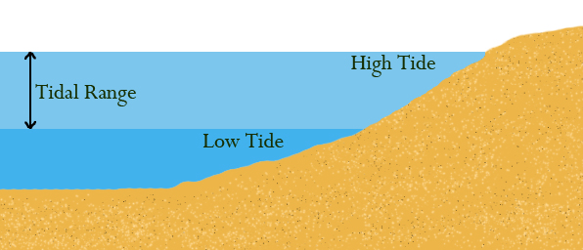
The Moon is the main cause of tides, but the Sun affects tides as well.
Twice during each month, the Sun, Moon, and Earth line up. This causes the gravity of the Sun and Moon to pull Earth’s water in the same direction. The result is an extra-high tidal bulge and an extra-low tidal dip. This is called the spring tide.
Spring tides occur during the New Moon and Full Moon phases.
During first and third quarter moons, the Sun and the Moon are not lined up with Earth. The result is a smaller tidal bulge and dip. This is called a neap tide.
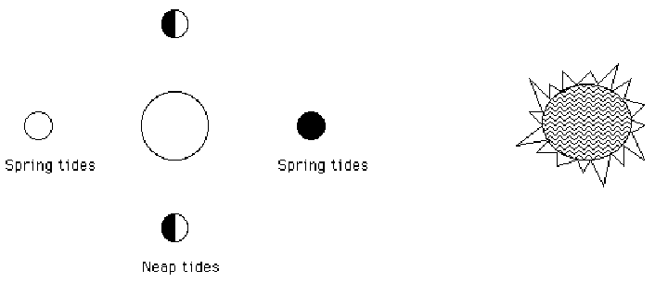
The energy of tides can be used to generate electricity. A tidal dam is built near a coast in the path of tidal water.

